#### **Top Ten Revision Tips**

1. Short bursts of revision (30-40 minutes) are most effective. Your concentration lapses after about an hour and you need to take a short break (5-10 minutes).
2. Find a quiet place to revise e.g. your bedroom, school, the library and refuse to be interrupted or distracted.
3. Make sure you don't just revise the subjects and topics you like. Work on your weaker ones as well.
4. Make your own revision notes because you will remember what you have written down more easily. Stick key notes to cupboards or doors so you see them everyday.
5. Rewrite the key points of your revision notes; read them out loud to yourself. We remember more than twice as much of what we say aloud than of what we merely read.
6. Use different techniques. Make your own learning maps, use post it notes to write key words on, create flash cards. Record your notes and listen to them. Ask friends and family to test you. Use highlighters to mark important points. Chant or make up a song/rap.

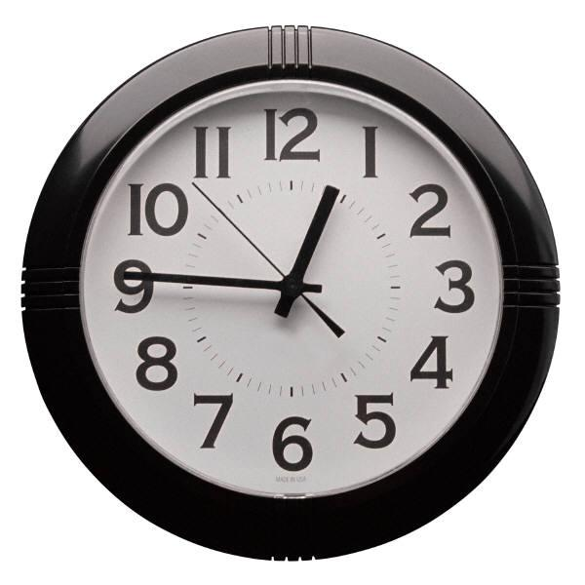

1. Practise on past exam papers or revision tests available on the internet. Initially do one section at a time and progress to doing an entire paper against the clock.
2. You will need help at some stage, ask parents, older brothers and sisters, teachers or friends. Use websites specifically designed for revision e.g. BBC Bitesize. <https://www.bbc.co.uk/bitesize/examspecs/zr8bmfr>
3. **Don't get stressed out!** Eat properly and get lots of sleep!
4. **Believe in yourself and be positive.** If you think you can succeed you will; if you convince yourself that you will fail, that's what will probably happen.

### **Effective revision**

To be effective, revision must be:

* **Active** - always work with a pen and paper, look for key points, test yourself. Never just sit down and read for a set period. Focus on tasks, not time. If you just read notes you’ll only retain about 10% of the information.
* **Organised** - always ask yourself at the start of a study session "what do I want to have completed in this session?" Have a plan for what you want to cover this week and this month. Have an overview of the priority areas in each subject.

### **Getting started on revision**

**Where?**   
Find a fixed place to study (a particular desk/room at home, a spot in the library, etc.) that becomes firmly associated in your mind with productive work. All the equipment and materials you need should be within reach, and the room should be well lit and ventilated, but not too comfortable! Turn your room into a positive learning environment. Keep books and notes on the desk to a minimum and decorate your walls with colourful notes and key facts. Music is fine as long as it helps you to study and blocks out distracting noises. The very best sound to study to is thought to be that of Baroque composers or Mozart. Experiments show that brains are positively stimulated and IQs boosted by such music.

**What?**  
Remember that it's all about being active and *focused on tasks, not time!* Know at the start of a session what you want to have completed by the end of the period. Make the tasks specific and realistic, not vague and large.

**How?**  
Always work with a pen and paper at the ready. Getting started is often the most difficult bit, so start by 'doing'. It usually helps to begin with a subject you like, move on to other less favoured areas, and then finish up with a favoured topic to maintain the interest.

**When?**  
Try to schedule your study for times when you are more mentally alert. Most people find their ability to focus deteriorates towards the end of the day. Getting revision done earlier in the day aids efficiency and also offers the reward of having time to relax after the work is done.

**Why?**  
Test your progress at the end of a study session. Ask yourself "what have I just learned?" Review the material covered in your revision session. Merely recognising material isn't enough - you must be able to reproduce it without the aid of the book or notes.

###### **REVISION - Do’s and don’ts**

**DO**

**1.** **Make a list of all the topics you need to revise:**  
Each subject that you are studying can be broken down into its constituent parts, with main sections, sub-topics and supporting details. A very useful start is to list out all the topics on the course according to this hierarchy and use this as a 'revision checklist' for the subject.  Tick topics off as you’ve learnt them.

**2. Create a realistic schedule.** 

Block the waking part of each day into three portions. Allow yourself one portion a day off and allocate subjects and topics to the remaining two. Put the schedule on display so that your family can see when you are available. It will also reassure your parents that you are in control.

**3**. **Plan ahead by working backwards**  
By using revision checklists in your various subjects, you should know what quantity of material has to be covered over the coming months. Start from the final date (end of May) and divide your revision up week by week, allowing some flexibility for unforeseen delays. Surprise yourself by being ready in time! Use the timetables and other sheets you have been given.

**4. Revise using your preferred learning style.**

Have you tried….. mindmaps, diagrams, colour, mnemonics, recording yourself and listening back to it, rewriting your favourite song using your revision notes for a topic as the words, walking round..

#### **DON’T**

**Just keep going!** The body and the mind need regular 'time-outs'. When you're tired, concentration is more difficult, you get distracted much easier and learning and memorisation is less effective. There comes a point in an evening study session when it is counter-productive to stay at the desk - nothing is going in and you are only tiring yourself further. Use breaks effectively, particularly after completing a task.

**Performing on the Day**

* **Get a good night's sleep**  
  While the temptation is to stay up half the night 'cramming' in more facts and figures, the evidence suggests this approach is counter-productive. In the context of a two-year course, an extra night's studying can make very little difference to your knowledge. However, having a mind that is refreshed, alert, and ready to respond to circumstances will obviously be of far greater benefit.
* **Arrive in plenty of time:** To perform well on the day, you need to be relaxed and to feel in control of the situation. This is difficult to achieve if you have missed breakfast and are stuck on a bus in traffic or standing on a train for 45 minutes as the exam time approaches. You will need about 15 minutes 'quiet time' to mentally rehearse your exam and run through your 'game plan' for the final time.
* **Have your equipment ready**  
  Each exam has its own requirements. Apart from properly functioning pens, pencils, rulers, etc, you may need a calculator for the Maths or Science exam. Drawing pencils may be required for diagrams in some subjects. A lot of nervous energy can be expended on last-minute hassle if these items aren't checked in advance.
* **Think positive**  
  On the day of the exam, remind yourself of the good things (the material you know well, the revision you have completed, all the past exam questions done, the good grades achieved) rather than dwelling on areas of weakness. Having that self-belief will give you the confidence to trust your judgement within the exam hall and 'hit the target'.
* **Maintain your focus**  
  There can be a lot of tension, drama, and hysteria in the air on the days of an exam. You want to keep the balance between maintaining your focus and interacting normally with your friends and classmates. Try finding a quiet spot *far from the madding crowd* to 'warm-up' before each exam and 'warm-down' afterwards. Surround yourself with people who are likely to add to the calm rather than add to the clamour.
* **Beware of post-exam analysis**  
  The more you participate in the exam post-mortem, the more confused and disheartened you are likely to become. You can't change what has happened, you can only focus on the present and this will need your full attention.

**Top Tips on Exam Strategy**

Success in exams involves two ingredients - having a thorough knowledge of the subject matter AND making the most of your knowledge in the exam through effective answering technique. Two students with identical knowledge and attainment levels can sit the same exam and their final grades can differ by as much as 25%. The difference is down to having an effective strategy and exam technique.

*Here are four golden rules to apply to all your GCSE papers:*

1. **Allow time to read the paper carefully**  
   The importance of reading the paper carefully and choosing your questions wisely cannot be emphasised enough at this stage. The natural inclination is always to start writing immediately and launch into a favoured topic. Resist the urge. Take your time. Be smart and size-up the paper before answering.
2. **Stick to your game plan**  
   An overall strategy should have emerged from your revision and exam preparation in each subject. This covers the areas you will tackle, the topics you will avoid if they appear on the paper, the sequence in which you will tackle the various sections, the style of answering you will employ in each subject, the amount of time you will allocate to answering each section. In some cases, this plan will work like a dream but there will always be surprises to deal with in some papers. Don't get flustered. Stick to your game plan, trust your judgement, and move on.
3. **Sweep up any mistakes**  
   In the pressure of the exam hall, it is easy to make elementary errors. These will sometimes have the potential to lose you a lot of valuable marks. Misreading the instruction on a question can render an entire answer invalid. You might have known the correct answer, but you didn't put it down. A simple miscalculation can lose you valuable time as you try to figure out the balancing item. Be disciplined with your time. Always leave a few minutes at the end to tidy-up errors. Simply changing a definition / formula / calculation at this stage could be the difference between a good and an average grade.
4. **Attempt all questions**  
   It is amazing how many exam scripts are handed up unfinished. Every year, capable students who just didn’t get time to finish the paper lose easy marks. Don't fall into this trap. Work on the basis that you will get an answer written for the required number of questions. Remember that it is much easier to get the first 20% of the marks for any question than the final 5%. You can always polish an answer further but, if there is no attempt made at part of a question, the examiner can't give you any marks. BUT if the instructions on the front of the paper tell you to answer a certain number of questions – stick to this - don’t answer too many!

###### **OTHER BITS!**



**Healthy Body = Healthy Mind**

**Food for thought**  
Eating a variety of healthy foods doesn't just give your body a boost, it also benefits your brain cells. Skipping meals may well give you extra cramming time, but it can also leave you hungry and unable to concentrate, So, eat regularly and sensibly. Think wholemeal sandwiches and fruit, rather than cakes and biscuits!

**Brain Fuel**

* Bread, pasta, cereals and potatoes are filling and packed with starchy carbohydrates, which release energy slowly, meaning you can keep going for longer. 
* Fruit and vegetables give you essential vitamins and minerals. Aim for at least five portions a day.
* Food like pasties, chips and crisps are high in fat. Unless you want to emerge from your room looking like Jabba the Hut, keep them for treats.
* Drink plenty of fluids. Dehydrated brains don't think clearly and water is healthier than sweet, fizzy drinks.
* Meat, fish, pulses, milk and dairy foods are good sources of protein. Moderate amounts are essential for a healthy diet.
* Make sure you eat breakfast on the day of an exam.
* If you’re not getting enough iron then you’ll damage your ability to concentrate for long periods of time and your energy levels will begin to drop. If hour-long sessions of revision are proving too much, try eating more red meat, eggs and leafy green vegetables like spinach.

**Exercise:** Staying in your room can seem like the best option when revision time is short. But a bit of the great outdoors can blow the cobwebs away and help you relax. If you can't get out, at least get up and out of your chair for a stretch and a wander. Better still, go for a swim or put those footie boots on and give your mind and body a workout.