Script Marks

Centre Number : 20666 Date Generated : 05/07/2024 01:17 Component : C120U90-1-RELIGIOUS STUDIES COMPONENT 2 CATHOLIC Series : 24G

Candidate Name Candidate Number Total Marks

87

|  |  |  |
| --- | --- | --- |
| **Item** | **Mark** | **Comment** |
| 1a | 2 |  |
| 1b | 5 |  |
| 1c | 8 |  |
| 1di | 13 |  |
| 1diAAC | 6 |  |
| 1dii | 12 |  |
| 2ai | 2 |  |
| 2aii | 2 |  |
| 2bi | 4 |  |
| 2bii | 5 |  |
| 2ci | 8 |  |
| 2cii | 8 |  |
| 2d | 12 |  |
| **Total** | **87** |  |

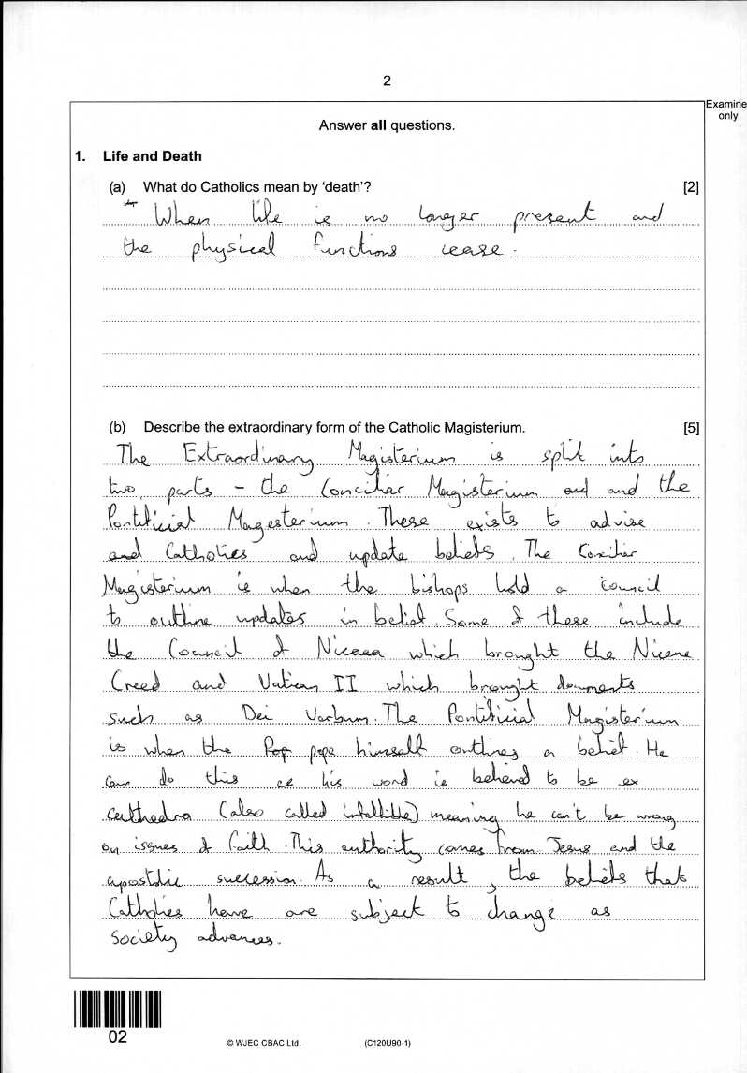

1a : 2

1b : 5

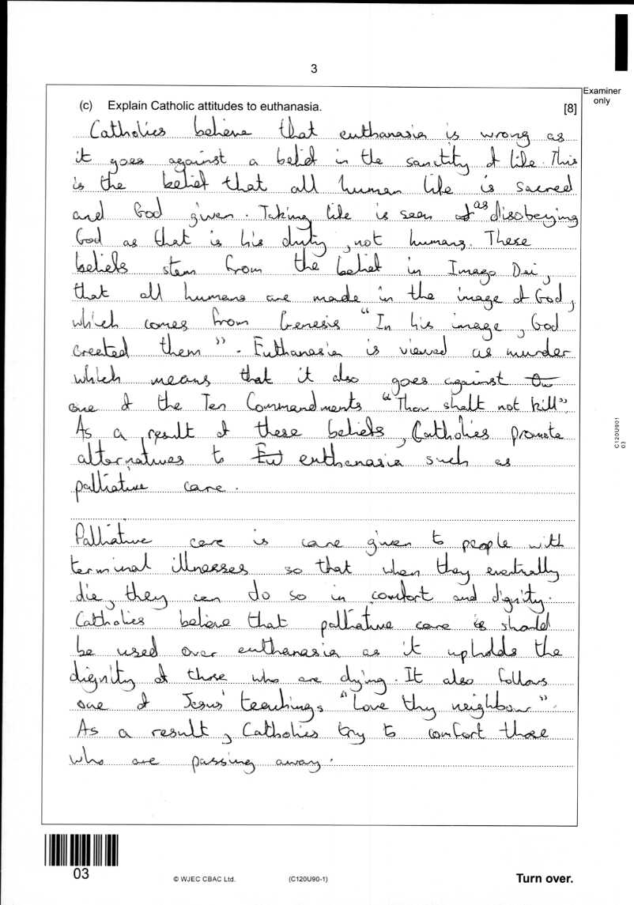1c : 8

1di : 13

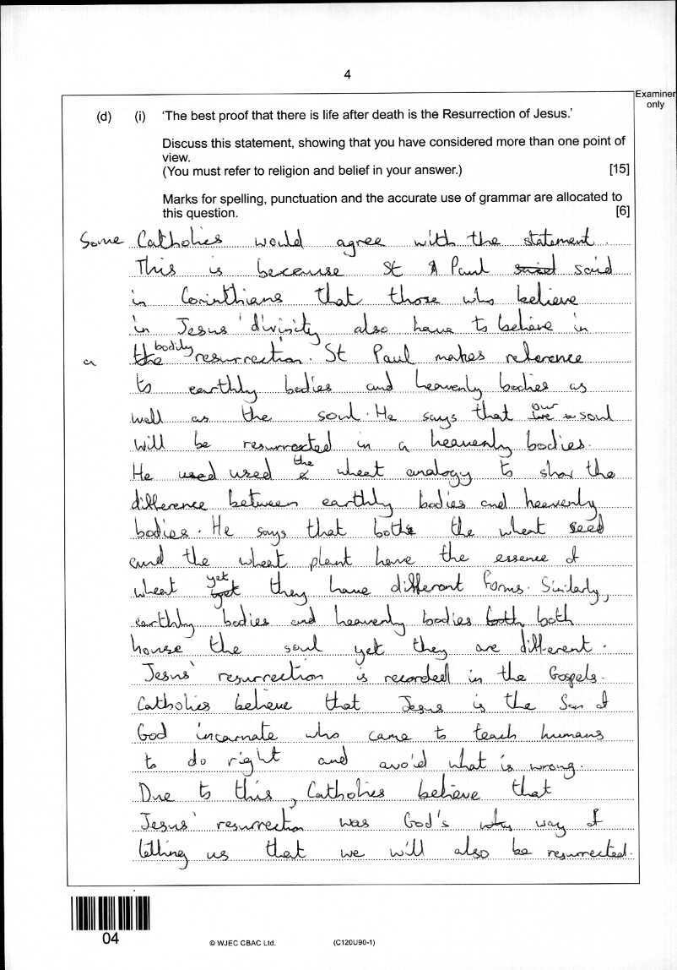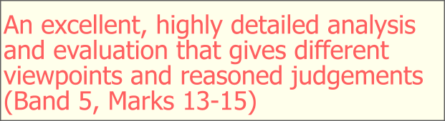

1diAAC : 6

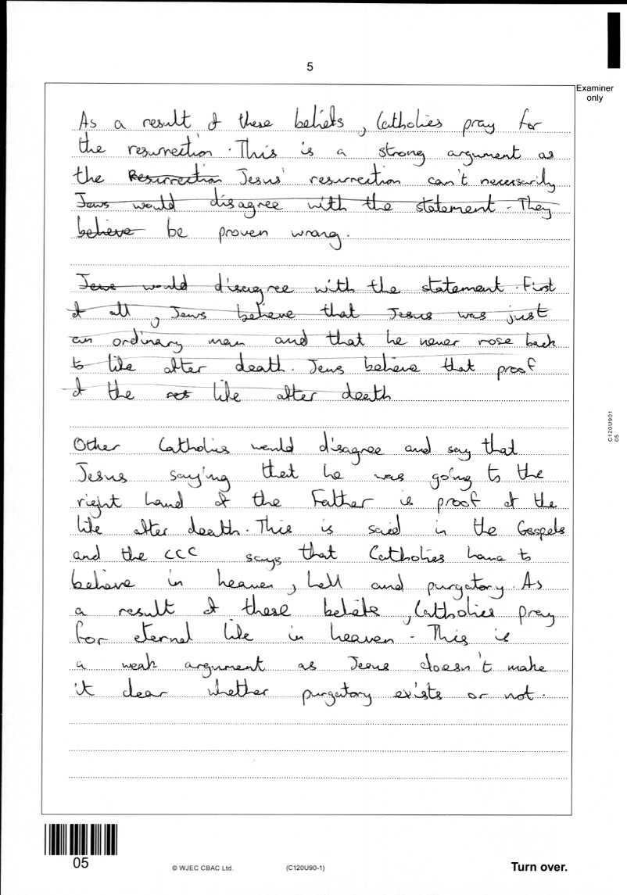

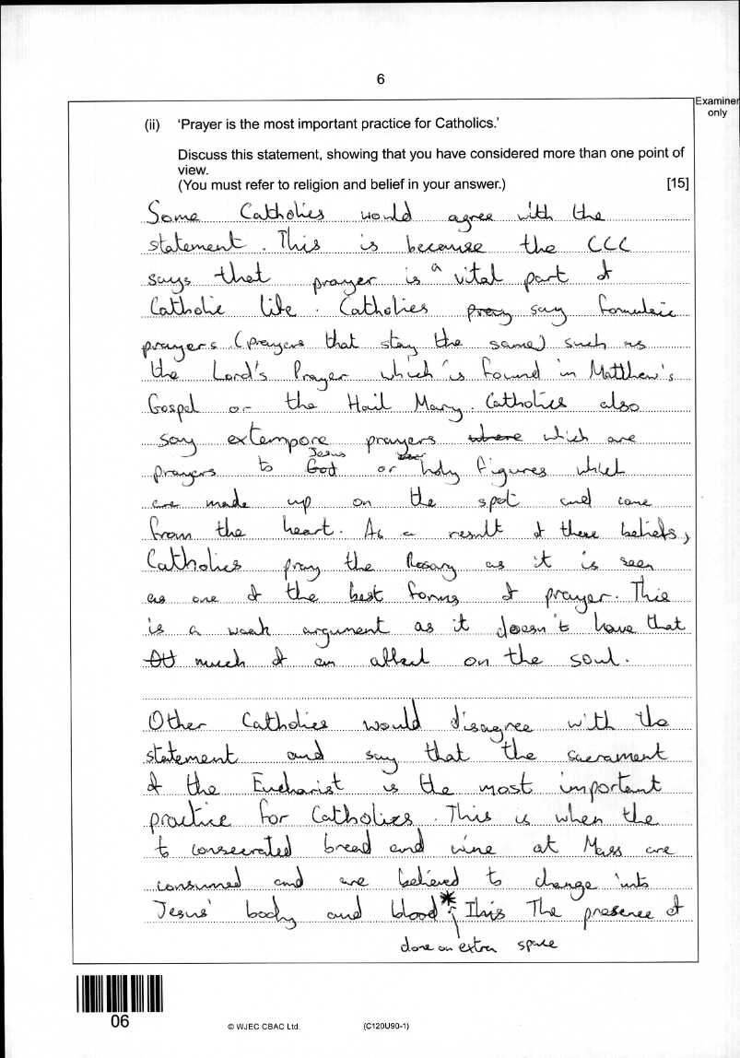

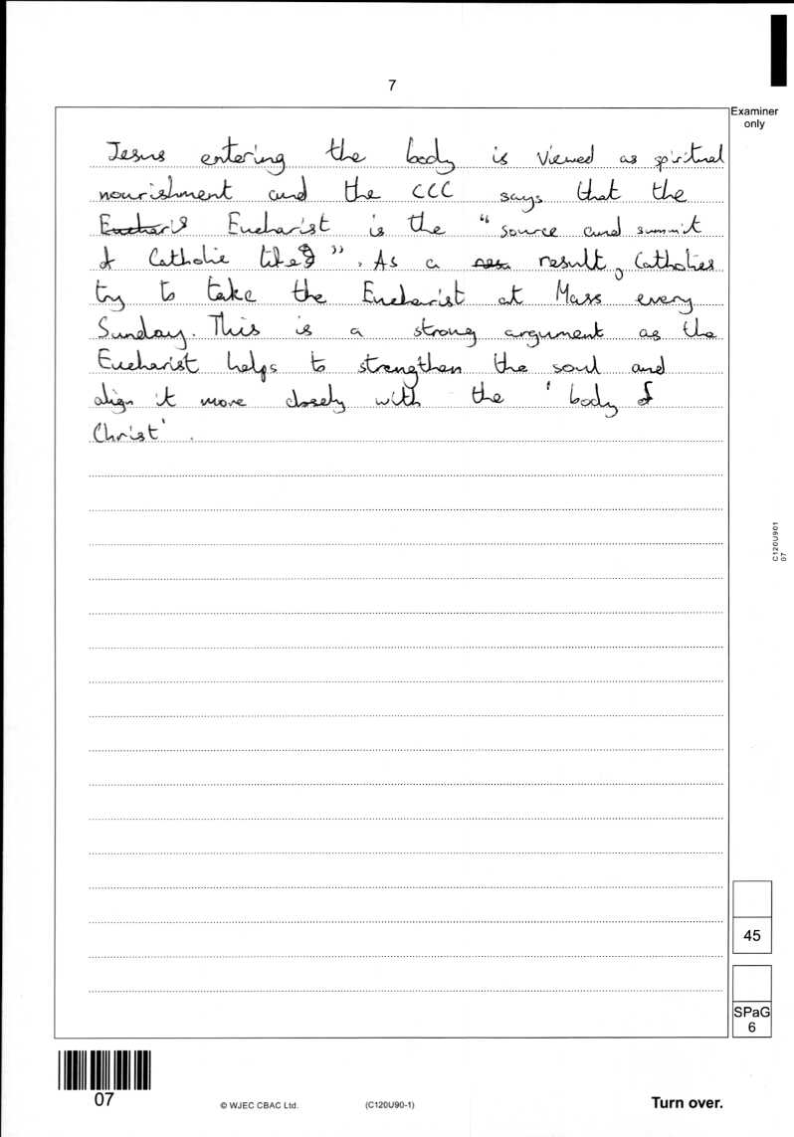

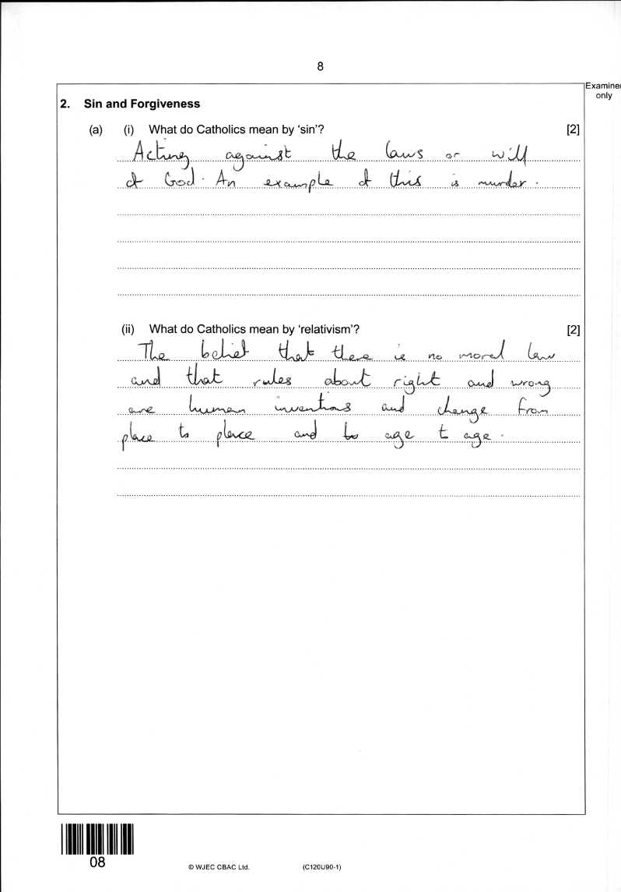2ai : 2

2aii : 2

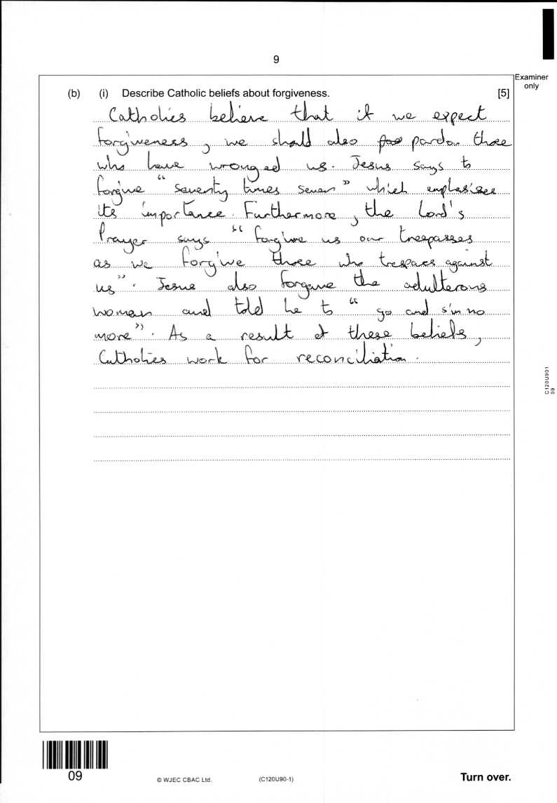2bi : 4

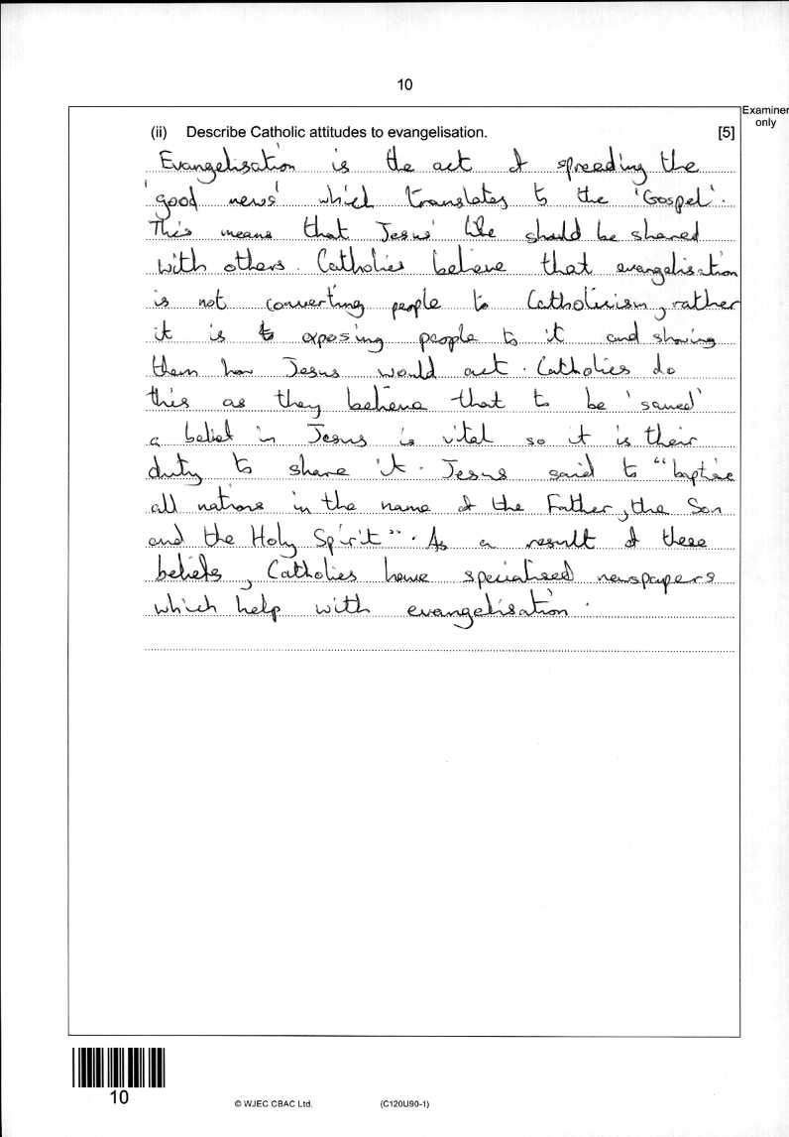2bii : 5

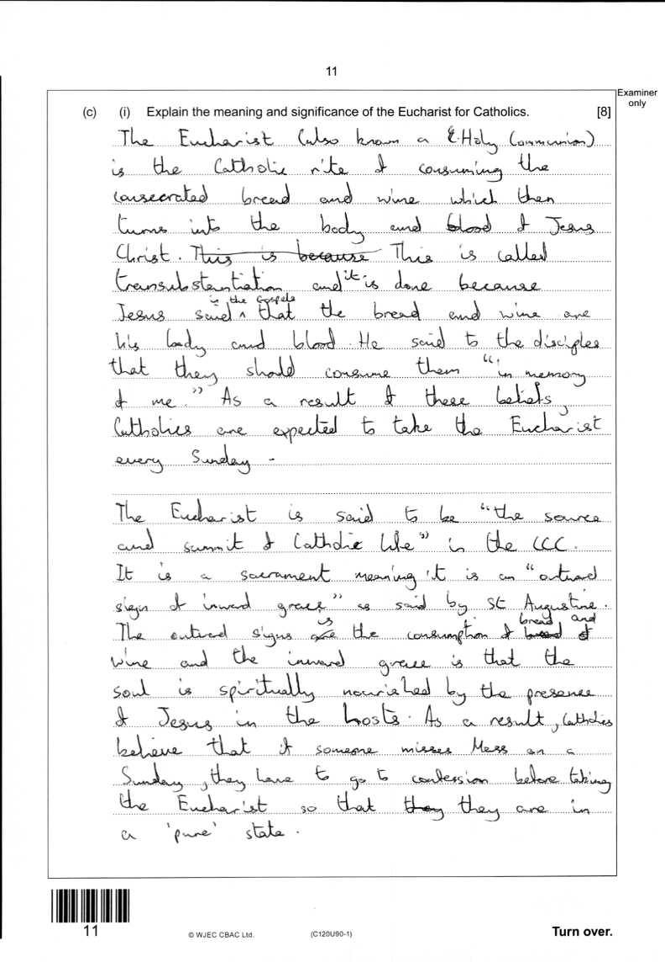2ci : 8

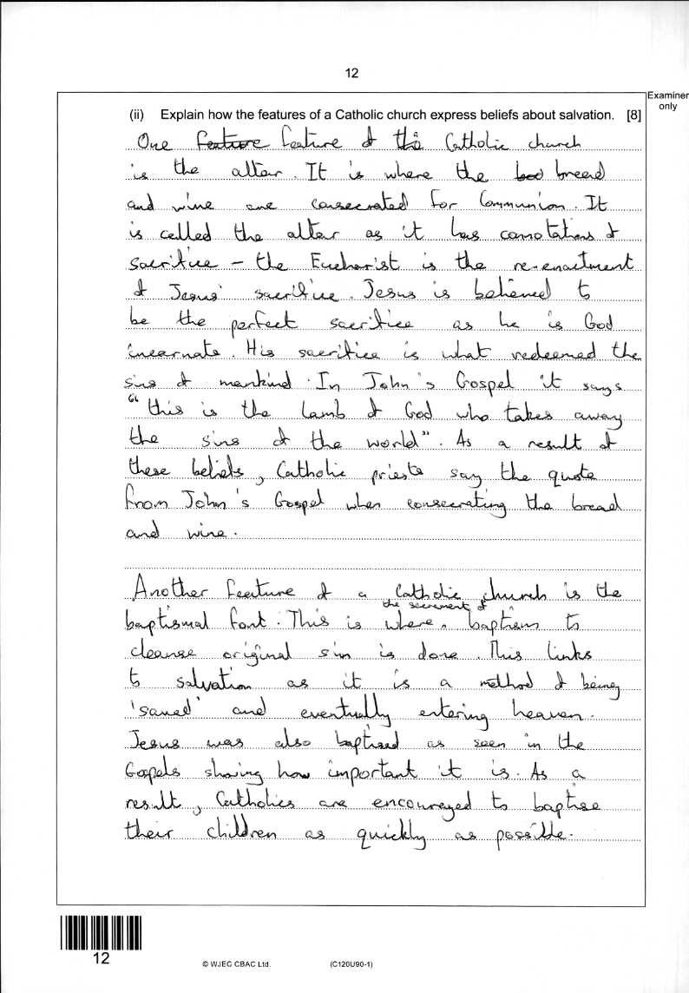2cii : 8

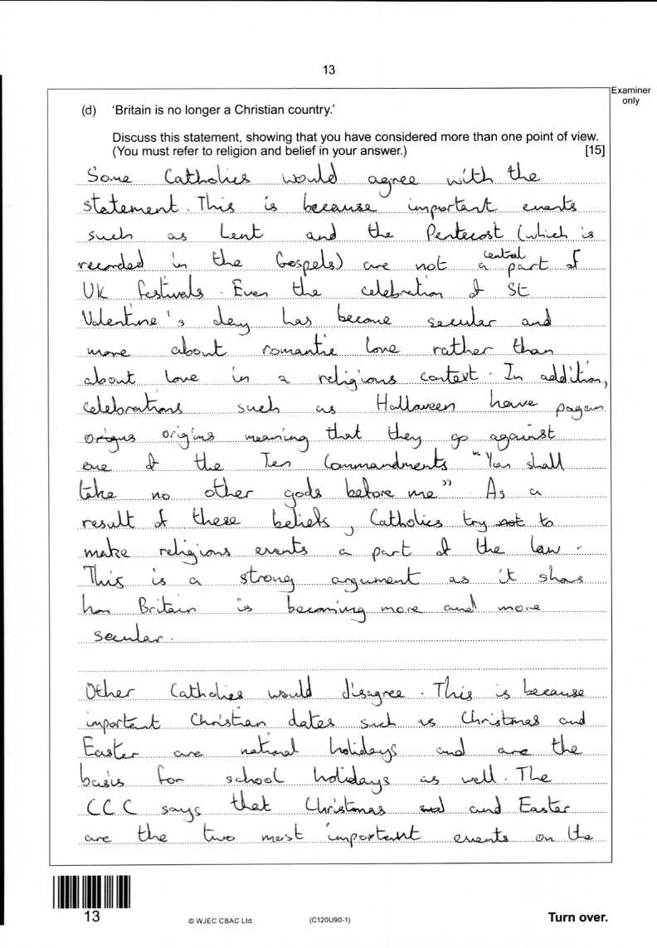2d : 12

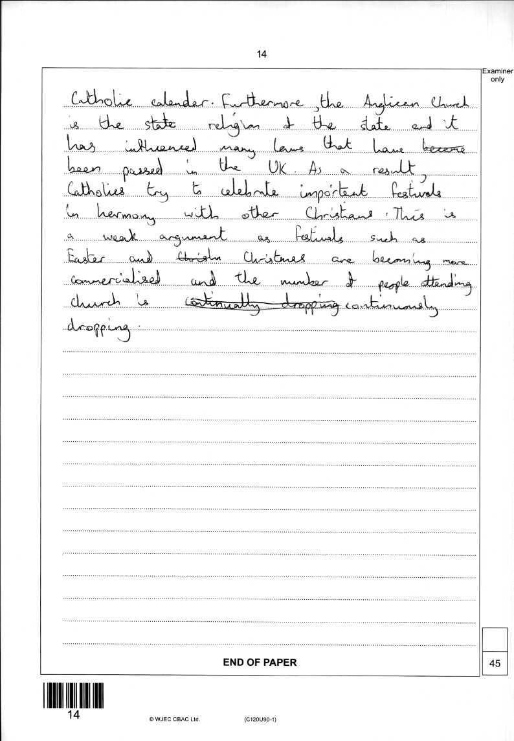

1dii : 12

