Script Marks

Centre Number : 20666 Date Generated : 08/07/2024 01:14 Component : C120U60-1-RELIGIOUS STUDIES COMPONENT 3 JUDAISM Series : 24G

Candidate Name Candidate Number Total Marks

53

|  |  |  |
| --- | --- | --- |
| **Item** | **Mark** | **Comment** |
| 1a | 2 |  |
| 1b | 5 |  |
| 1c | 8 |  |
| 1d | 11 |  |
| 2a | 2 |  |
| 2b | 5 |  |
| 2c | 8 |  |
| 2d | 12 |  |
| **Total** | **53** |  |

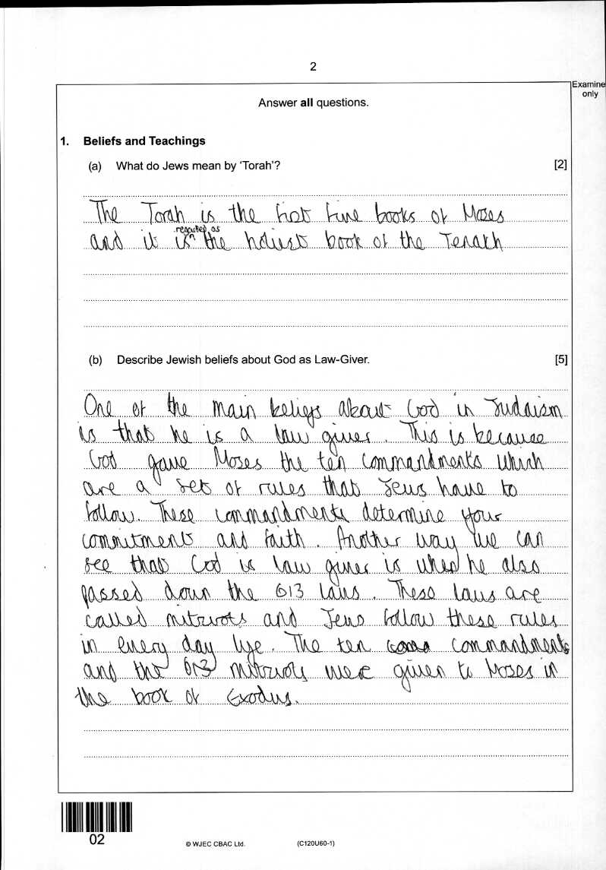

1a : 2

1b : 5

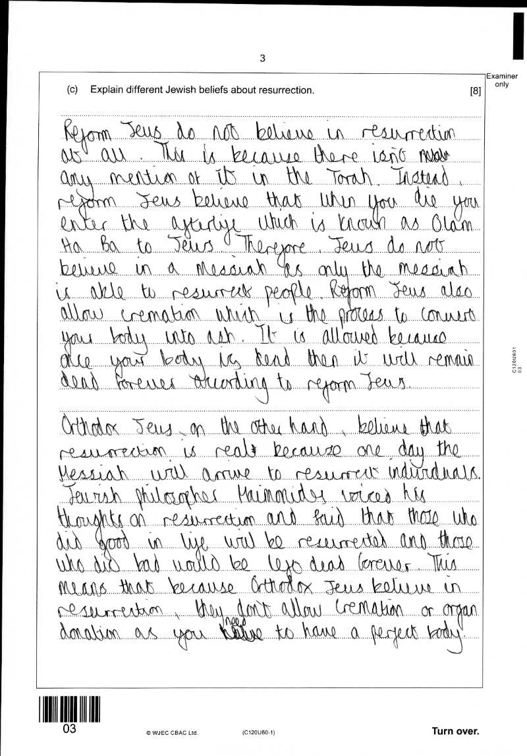1c : 8

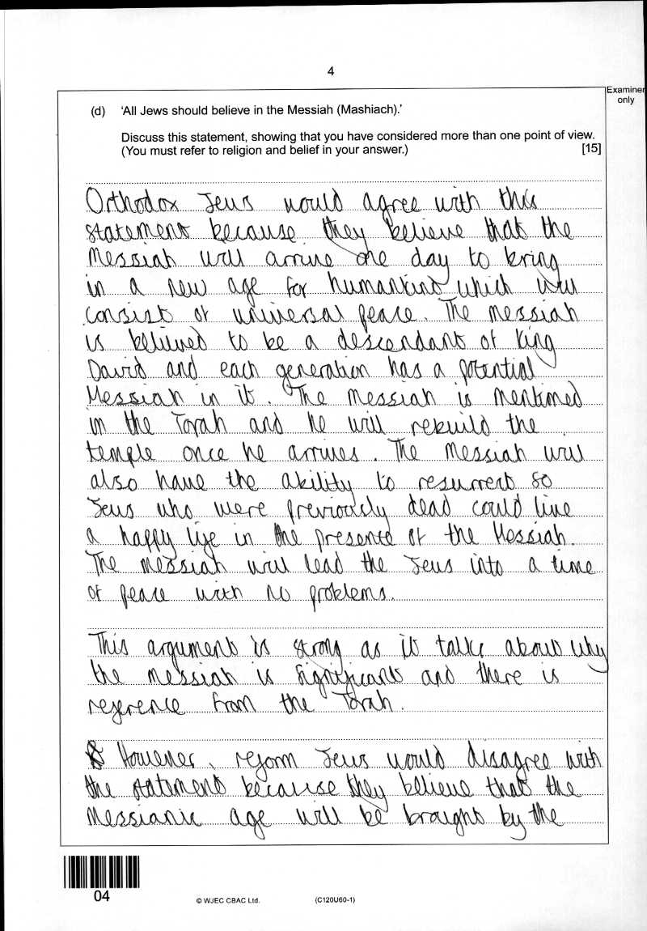1d : 11

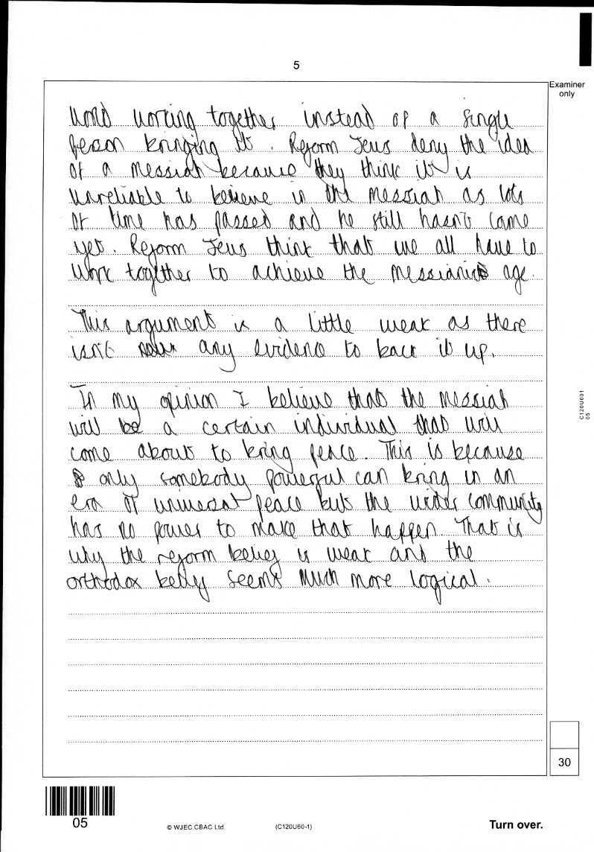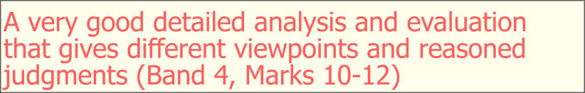

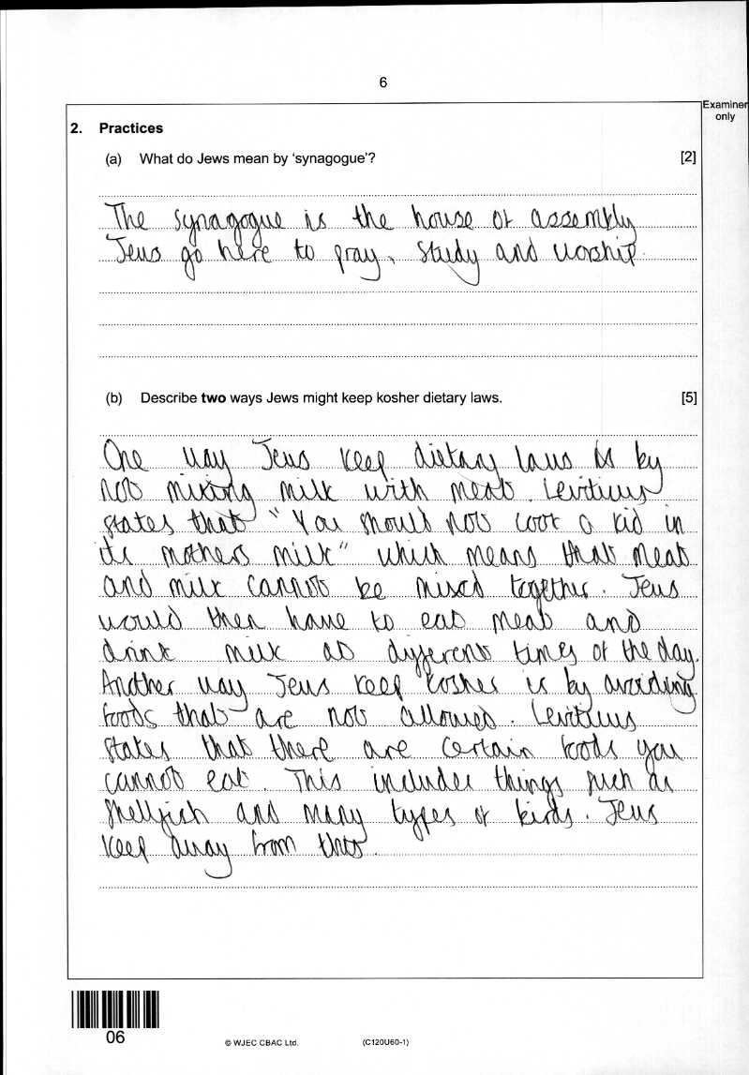2a : 2

2b : 5

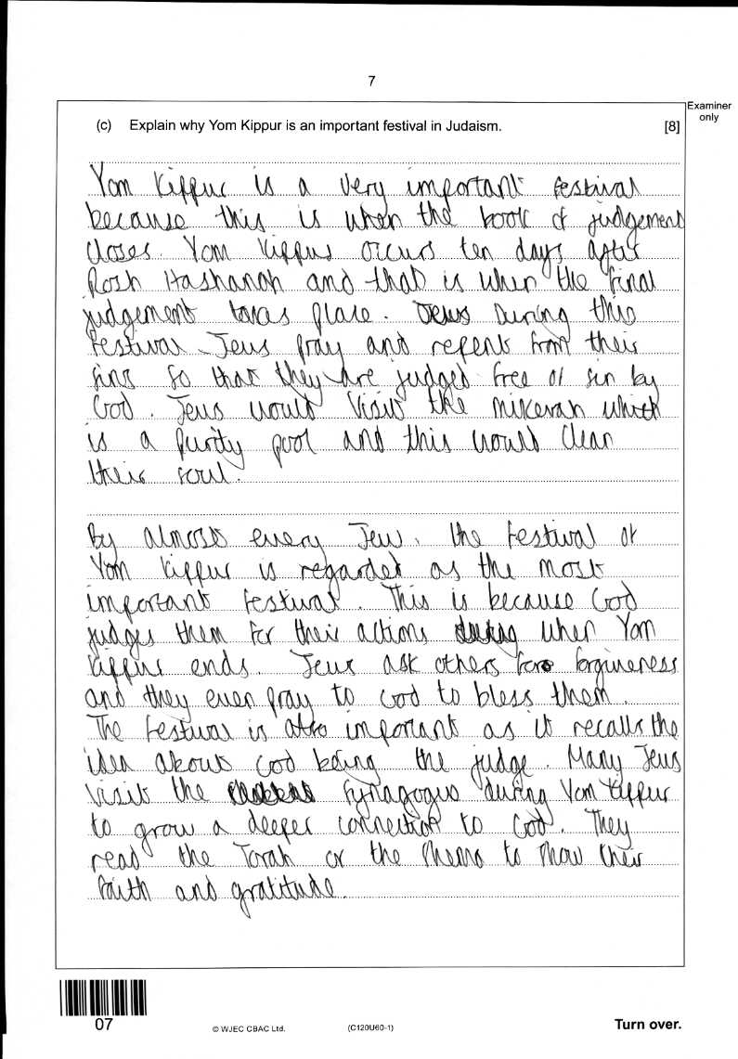2c : 8

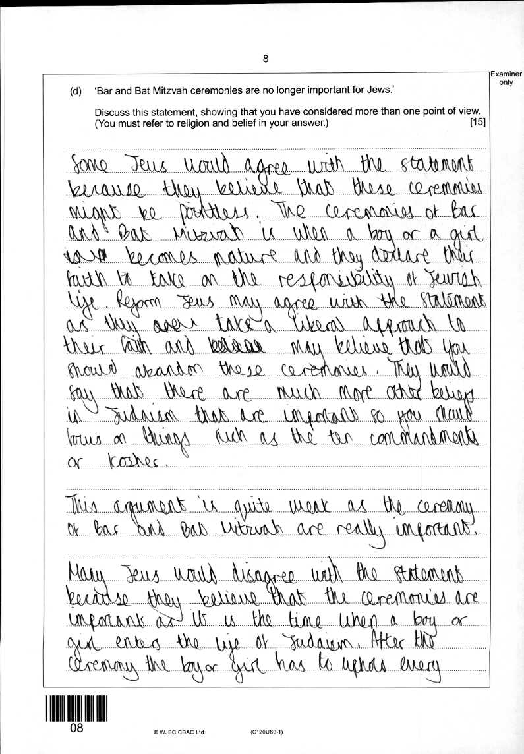2d : 12

