Genesis 2

Sanctity of life / Imago Dei

Genesis 1

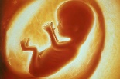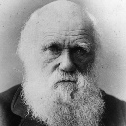

Catholic views towards abortion

Anglican views towards abortion

Jewish views towards abortion

Humanist views on quality of life and abortion

Scientific theories of creation

Genesis: what does it tell us about God?

Genesis: Roles of humans

Liberal view of Genesis

Fundamental view of Genesis

**Origins and meaning 1**

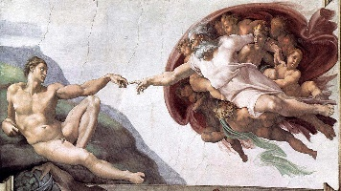

Beliefs depicted about creation in Michelangelo’s Creation of Adam

Bible interpretations

The Bible

Jewish beliefs about creation

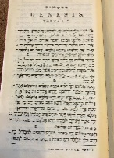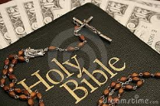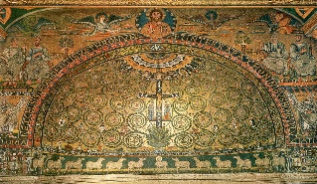

Multi-faith society

Inter-faith dialogue

SVP

CAFOD

Catholic social teaching

Beliefs depicted in The Tree of Life Apse Mosaic

The Torah

**Origins and meaning 2**