Free will

The Fall

Moral evil is:

Natural evil is:

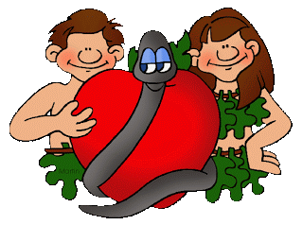

God’s goodness

Irenaeus and Hick

Hume/JL Mackie

The inconsistent triad

St. Augustine - Enchiridion

Non-religious views

Jewish views

**Good and Evil.**

The Incarnation

The incarnation and evil

Jewish views on the Trinity

The Trinity/ Church development /St. Augustine and the Trinity

Christian responses to suffering

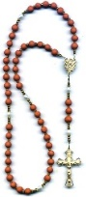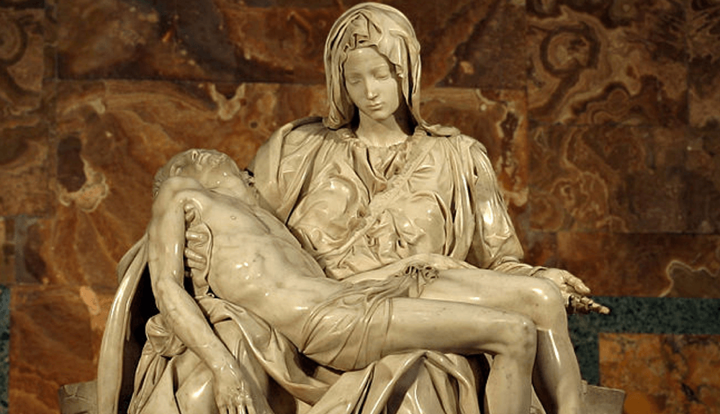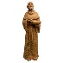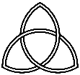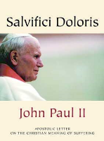

**Good and Evil.**

Jewish views

The Rosary

Pilgrimage and Lourdes

Jewish views

Michelangelo’s Pieta

Statues and sculptures

Jewish views

Conscience

Natural Law

Jesus as moral authority

The Beatitudes