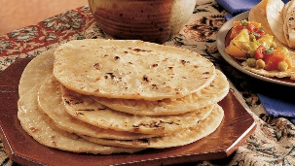
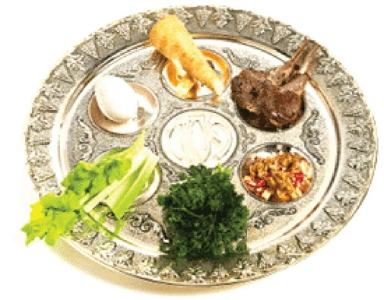
Revision: Judaism- Practices
Festivals – Rosh Hashanah
Festivals- Pesach
Festivals- Sukkot
Festivals- Yom Kippur
Dietary laws
Daily life

