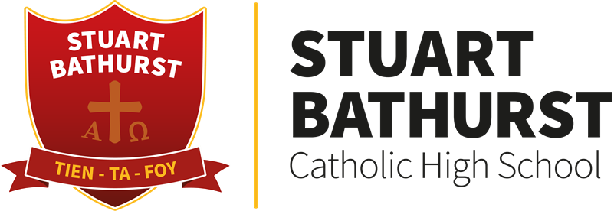

Religious Education

Sin and Forgiveness

Exam Question Plans.

**Purpose of this session:**

1. Exploring exam skills.
2. Understanding how to use plans to help your revision.

**Types of exam questions:**

2,5,8 and 15 mark questions will be asked in the exam.

**2 mark questions.**

Key concepts- learn off the definition.

**Describe- 5 mark questions.**

1 KISS paragraphs or 2 PEE paragraphs

**Explain- 8 mark questions.**

2 KISS paragraphs or 4 PEE paragraphs

**Evaluate- 15 mark questions.**

2 KISSJO paragraphs

3 PEE arguments for and 3 PEE arguments against and a judgment (PEE opinion)

Explain Catholic beliefs about forgiveness. (8)

Explain Catholic teachings on capital punishment (8)

Explain the different aims of punishment. (8)

Explain why the resurrection is so important for Catholics. (8)

Explain Catholic beliefs about salvation. (8)

Explain why some Christians agree with capital punishment and why some do not. (8)

Explain how the features of a Catholic church reflect beliefs. (8)

Explain the importance of Mary for Catholics. (8)

Explain the nature of the Church. (8)

Explain the meaning and effects of the sacraments of healing. (8)

Explain the meaning and effects of the sacraments of initiation. (8)

Describe the architecture of a Catholic church. (5)

Describe the Catholic Church’s view of salvation outside of the Church. (5)

Describe what it means to say the Church is the body of Christ. (5)

Describe the importance of the Church as the body of Christ. (5)

Explain how and why the Church is involved in Evangelisation. (8)

Explain the importance of Evangelisation for Catholics. (8)

Explain the importance of the Eucharist for Catholics. (8)

Explain the meaning and effects of the sacraments of service. (8)

Explain the diversity of faith, belief and culture in Britain as expressed through laws, festivals and celebrations. (8)

Describe the diversity of faith and belief in Britain. (5)

|  |  |
| --- | --- |
| ‘Only God should be allowed to take life’ 15marks | |
| Agree | Disagree |
| Judgement | |

|  |  |
| --- | --- |
| ‘Evangelism isn’t appropriate in a multi-faith society like the UK’ 15marks | |
| Agree | Disagree |
| Judgement | |

|  |  |
| --- | --- |
| ‘Without the Sacraments we cannot receive God’s Grace.’ 15marks | |
| Agree | Disagree |
| Judgement | |

|  |  |
| --- | --- |
| ‘The Mass is the best way for Catholics to receive God’s Grace.’ 15marks | |
| Agree | Disagree |
| Judgement | |

|  |  |
| --- | --- |
| ‘Jesus died so that everyone may be saved.’ 15marks | |
| Agree | Disagree |
| Judgement | |