STUART BATHURST CATHOLIC
HIGH SCHOOL

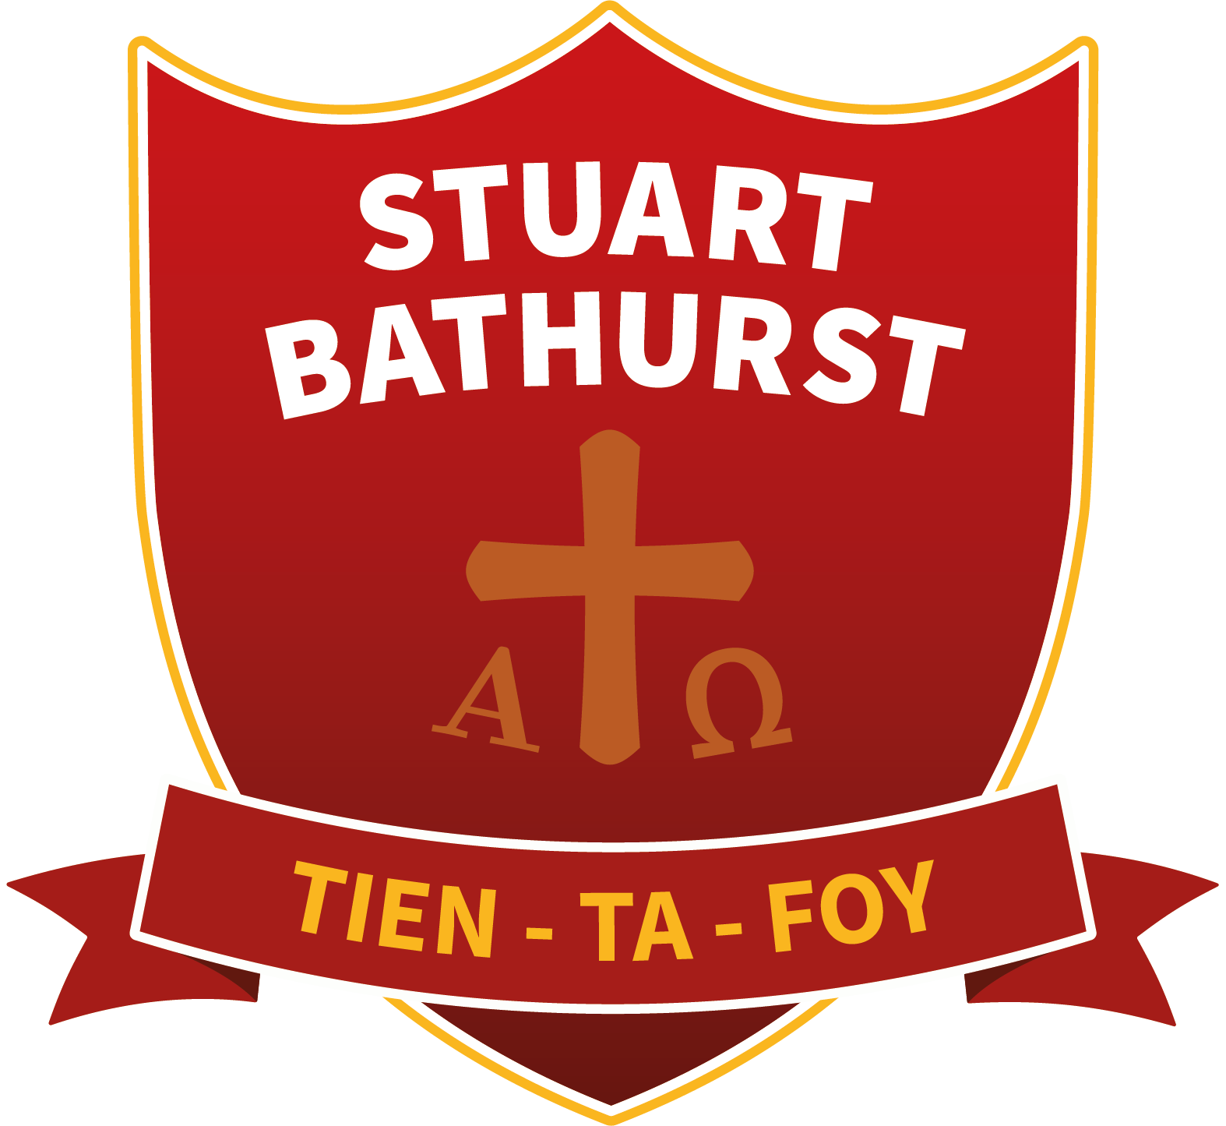

PRAYER AND LITURGY POLICY 2023

Mission Statement

“To bear witness to the Gospel Values and act always with a steadfast determination to do and be of our best.”

School Prayer
Tien-Ta-Foy!
Give us O Lord:
a steadfast Faith;
a steadfast commitment;
and the steadfast determination to always do, and be of, our best.
Amen.

As a Catholic school we aim to provide an environment where background, personal growth and faith are brought into harmony.

We seek this through the subjects we study, in the light of the Gospel and by providing an experience of being served, accepted and valued in a way that reflects the example and attitude of Jesus.

At Stuart Bathurst Catholic High School we, therefore, aim to operate an educational philosophy which:

- Places prayer, liturgy and worship at the heart of school life; both celebrating and fostering the development of faith in each individual within the school community.

- Recognise the importance of a purposeful link between home, parish, school and community as a preparation for the student’s role as a Christian in the modern world.

- Strives to make our student’s experiences of relationships within the school productive and positive and seeks to cherish and develop what is good through mutual respect and understanding.

- Promotes the growth and development of the whole person to their full potential by ensuring that their curriculum experience is within a Catholic context and where the student can be supported in acquiring skills, knowledge, positive attitudes and moral values.

- Provides a Christ centred setting whereby all can live, experience and celebrate the love of Jesus.

PRAYER AND LITURGY POLICY 2023

COLLECTIVE WORSHIP STATUTORY REQUIREMENTS
The 1988 Education Act requires that every school provide a daily act of worship for all pupil

We understand collective worship to be coming together to show reverence, worship and love of God. As a Catholic school, the content and form of our worship, through prayer and liturgy, must reflect the doctrine and traditions of the Catholic Church, along with a deep love of Almighty God, Our Lady, Angels and the Saints.

Within the Catholic school day collective worship must take place either as a whole school experience or that within year group assemblies or form time. Moreover, the Catholic ethos should permeate every minute of our school day and be evidenced though visual displays and in the behaviour of staff and pupils.

In a Catholic school, our main act of formal worship must be the coming together to share in the weekly sacrifice and offering of the The Mass in the school Chapel. This will be further supported through or observance of Holy Days of Obligation.

AIMS AND PURPOSES OF COLLECTIVE WORSHIP

- To provide the opportunity for all pupils to share in the worship of Almighty God
- To promote a common ethos with shared values and reinforce positive attitudes
- To provide an opportunity for all to consider the purpose and meaning of life
- To encourage participation and response
- To provide the opportunity for pupils and staff to listen and contemplate on the teachings of Christ and His Church
- To enable all to become more aware of their faith through scripture readings, prayers, hymns and most importantly sacramental worship such as The Mass
- To reinforce the feeling of a supportive family in Christ through a collective act of worship
- To help pupils develop moral and spiritual values which should support them in their life
- To provide opportunities to celebrate achievements and to share in special festivals of the liturgical year
- To familiarise pupils with The Rosary, The Chaplet of Divine Mercy and The Stations of The Cross
- To provide an opportunity to give thanks to Almighty God for all His gifts
- To promote cohesion and respect for people across all faiths

CONTENT
Our act of prayer and liturgy should include many aspects of life pertinent to our pupils. The following may be used as a guide:

- Celebration of the main festivals of The Church and Diocese throughout The Church year
- Reading and meditating on the Gospels, Bible readings and other sacred texts or materials published by The Church i.e. Encyclicals, Catechism
- Using examples of exemplary lives taken from a wide variety of persons i.e. Saints and everyday people
- The Catholic Social Teachings of The Church and how these can be lived out authentically and fully both individually and collectively - in school, in the local community and globally
- Being aware of personal and global issues which reflect teachings of The Church, for example poverty, lack of freedom, immorality, abortion and misuse of power etc
- Greater knowledge of the work of organisations such as CAFOD, LIFE, and nearer to home Father Hudson Society
- Greater knowledge and understanding of places of pilgrimage, both national and international
- Celebration of successes of members of the community
- Performance and presentations from members of the community
- Input from visiting speakers/experts
- To express our support and love for those in our community with deep personal and social challenges
- To make positive use of the media to reinforce Catholic Doctrine and Teaching

WHOLE SCHOOL ORGANISATION: PARTICIPATION AND EXPECTATIONS
All students and staff will:
- Attend and participate in whole school Masses including those on Holy Days of Obligation
- Have the opportunity to attend and contribute to weekly Mass in the school Chapel
- Have the opportunity to attend and contribute to Collective Worship each week for all year groups – referred to as Prayer and Liturgy.
- Participate in daily prayer via form time using the Collective Worship Manual
- Have use of the Chapel during lessons/prayer and liturgy and all collective worship/Masses
- Participate in and contribute to the Discipleship programme in Year 7 (Induction Programme)
- Participate and contribute to the whole school retreat programme
- Participate in, contribute to and lead on Charitable events (fund raising etc)
- Have access to the Prayer and Reflection room (Daily) – to support private prayer and personal intentions

All students will:
- Attend and participate in Religious Education lessons
- Have the opportunity to join the Chaplaincy Team
- Have the opportunity to prepare and lead prayers via form time, weekly masses, whole school events, prayers before each lesson
- Participate in prayer at the beginning of all lessons

All staff will:
- Be enabled to support the prayer life of the school via:
  - participating in induction programmes and all Catholic Life CPD
  - Participating in the weekly Catholic Life Briefing
  - Leading on prayer via: form time, Catholic life Briefing, Masses
- Have the opportunity to join the Chaplaincy Team
- Have access to specialist support to aid delivery of and participation in, prayer and liturgy at all levels
WHOLE SCHOOL ORGANISATION: EXPECTATIONS
Students by the end of Key Stage 3 will:
- Know the common prayers of the Church – Our Father, Hail Mary
- Know the school prayer
- Recognise how prayer is integral to faith development
- Understand how the school Mission Statement is a reflection of the wider mission of The Church.
- Participate in at least 3 weekly form group led masses in the Chapel
- Participate in whole school masses each year – bringing identity and inclusion
- Know the cycle of the Liturgical Year
- Know and understand different forms of prayer and liturgy (e.g. difference between a Mass and a Liturgy)
- Have had the opportunity to experience prayer and liturgy through a retreat programme
- Have had the opportunity to receive the Sacraments e.g. Reconciliation, Eucharist

Students by the end of Key Stage 4 will:
- All of the above and…
- Know the common prayers of The Church and a broader range of prayers which enable a stronger relationship with God, Mary and The Saints.
- Have participated in a Leaver’s Mass which reflects their faith journey as part of the family of Stuart Bathurst Catholic High School
- Develop confidence in planning and leading acts of prayer and liturgy
Students by the end of Key Stage 5 will:
- All of the above and…
- Be confident in leading acts of prayer and liturgy with younger students
- Have the opportunity to be leaders of the Student Chaplaincy team
- Have the knowledge, appreciation and understanding of how prayer and liturgy can support living a vocational life beyond school
- Develop a sense of spirituality which will support them into adulthood
COLLECTIVE WORSHIP WITHIN THE WIDER SCHOOL
- All departmental and pastoral meetings begin with a prayer
- Subject areas have their own scriptural reference for reflection and also subject focused prayers
- The SAINT daily pastoral programme ensures worship is at the beginning of each daily session – uniting the whole school community in developing their relationship with God and each other
- SAINT daily activities enable ALL students to develop an appreciation of faith in action and embrace and embody the Social Teachings of The Church
RESOURCES

- The best resource is a teacher who can reflect a full Catholic life based on Church teaching and in depth knowledge of the Faith and traditions of The Church
- The support of the Lay Chaplain for form tutors and all staff, in preparation of weekly masses and all relevant acts of worship
- Books and posters etc readily for all to use in support if delivery of collective worship
- Availability of the Chapel
- Access to appropriate music to enhance student experience
- Visible and engaging displays of ways in which one can gain access to various organisations helpful to young people i.e. LIFE, charities, places of pilgrimage etc.
- Access to use of the media through DVD, CD, EWTN Channel, and the Pope’s new channel on YOUTUBE updated daily

HOW COLLECTIVE WORSHIP WILL ENRICH THE EXPERIENCES OF STAFF AND STUDENTS

Collective worship (Prayer and Liturgy) will enrich the experiences of students in a variety of ways and on different levels:

- Enable students to reflect on issues that relevant to the school and local community
- To allow staff and students the opportunity to enter into dialogue with those of a similar faith
- Assist staff and students in their moral, spiritual and vocational development through their relationship with God
- Promoting a cohesion and shared understanding within the community
- Enabling students to respond to crisis in an appropriate manner, exploring feelings and responses
AREAS OF DEVELOPMENT

- To ensure the school adheres to all aspects of the new Prayer and Liturgy Directory as directed by the Archdiocese of Birmingham
- To audit use of collective worship (Prayer and Liturgy) resources in form time
- To investigate cross-curricular activities which enrich student experiences of collective worship
- To deliver INSET in use of materials and offer guidance for prayer
- To review this policy annually and monitor its effectiveness and implementation

