STUART BATHURST CATHOLIC HIGH SCHOOL

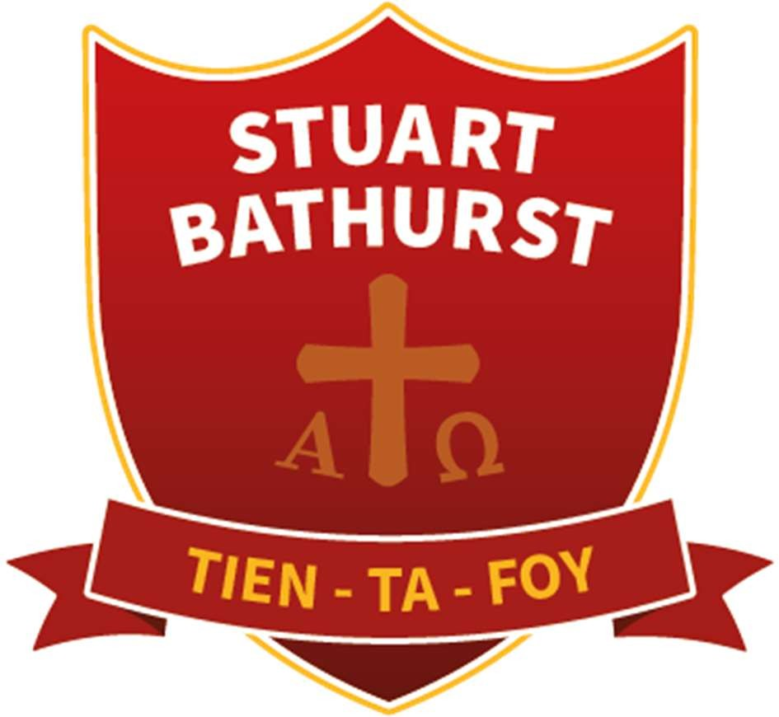

POLICY FOR CAREERS EDUCATION, INFORMATION, ADVICE & GUIDANCE (CEIAG)

Mission Statement

“Tien-Ta-Foy” – Keep the Faith
As a Catholic school we aim to provide an environment where background, personal growth and faith are brought into harmony.

We seek this through the subjects we study, in the light of the gospel and by providing an experience of being served, accepted and valued in a way that reflects the example and attitude of Jesus.

At Stuart Bathurst Catholic High School we, therefore, aim to operate an educational philosophy which:

- Places prayer, liturgy and worship at the heart of school life; both celebrating and fostering the development of faith in each individual within the school community.

- Recognise the importance of a purposeful link between home, parish, school and community as a preparation for the student’s role as a Christian in the modern world.

- Strives to make our student’s experiences of relationships within the school productive and positive and seeks to cherish and develop what is good through mutual respect and understanding.

- Promotes the growth and development of the whole person to their full potential by ensuring that their curriculum experience is within a Catholic context and where the student can be supported in acquiring skills, knowledge, positive attitudes and moral values.

- Provides a Christ centred setting whereby all can live, experience and celebrate the love of Jesus.

Stuart Bathurst CATHOLIC High School POLICY FOR
CAREERS EDUCATION, INFORMATION, ADVICE AND GUIDANCE 2022/2023

Introduction:

A young person’s career is their pathway through learning and work. All young people need a planned programme of activities to help them make 14-19 choices which are right for them and to enable them to have the necessary skills to be able to manage their careers throughout their lives. Schools and colleges have a statutory duty to provide careers education in Years 7-13 and to give students access to high quality careers information, advice and guidance. The policy is developed and reviewed annually. It is based on current good practice from the Careers Development Institute and is guided by the ‘Gatsby’ benchmarks, to ensure best practice and to conform to statutory requirements aptly demonstrated by our school moto ‘To do and be of our best’

Aims and Commitment of CEIAG:

Stuart Bathurst Catholic High School is committed to providing a planned program of careers education for all students in Years 7-13 and information, advice and guidance in partnership with the local Connexions Service and external providers/professionals.

Stuart Bathurst Catholic High School endeavors to follow the National Careers Strategy for CEIAG (December 2017), Quality Standards for Young People’s IAG and current good practice guidelines DCSF IAG Strategy, DCSF Principles of Impartial Careers Education and other relevant guidance from QCA and OFSTED.
CEIAG link to whole school aims and development plans. SIP/SEF

At Stuart Bathurst Catholic High School our careers’ mission statement aims for all students to: -

- Successfully enter Employment, Education or Training (EET) at the right level, after leaving Stuart Bathurst Catholic High School,
- Have completed a Work Experience Programme (Year 10 and Sixth Form students)
- Have knowledge and understanding of current careers and study opportunities available to them as an individual.
- Have had at least three opportunities for employer engagement per academic year (Year 7 – 13)

Development:

This policy was developed and is reviewed annually through discussion with teaching staff; the School’s Connexion personal adviser(s), Black country careers partnership advisors, students, parents, governors, advisory staff and other external partners (e.g. education business partnership). · Links with other Policies It supports and is underpinned by key school policies including those for teaching and learning assessment, recording and reporting achievement, Catholic Values, work related leaning and enterprise, equal opportunities and diversity, health and safety, gifted and talented, and special needs.

Objectives of CEIAG:

The careers programme is designed to meet the needs of all students at Stuart Bathurst Catholic High School. It is differentiated and personalised to ensure the progression through activities which are appropriate to students’ stages of career learning, planning and development.

Students are entitled to careers education, information, advice and guidance which meets professional standards of practice and is person-centred, impartial and confidential. It will be integrated into students’ experience of the whole curriculum and be based on a partnership with teachers, students and their parents or carers. The programme will promote equality of opportunity, inclusion and anti-racism; it will comply with the disability and discrimination acts, celebrate diversity and challenge stereotypes.

Implementation of CEIAG:

Responsibility for CEIAG within Stuart Bathurst Catholic High School lies with the Assistant Headteacher and Careers Leader (Mr Terry Walsh). Work experience is planned and implemented for Year 10 and Sixth Form students by the Careers Leader. Mr Walsh can be contacted on (0121) 5561488 or via email terence.walsh@stuart-bathurst.org.uk

The Careers Lead is responsible for the planning, coordination, implementation and management of the CEIAG and WRL programme, materials, resources and opportunities.

All staff contribute to careers education, information, advice and guidance through their roles as Form Tutors and subject teachers. Specialist sessions are delivered by external providers, staff with responsibility for careers and Form Tutors. Careers information is available in the Learning Resource Centre.

Staffing:
All staff contributes to careers education and guidance through their roles as tutors and subject teachers. Specialist sessions are delivered by form tutors during Catholic Values. The CEIAG programme and policy is planned, monitored and evaluated by the careers co-ordinator in consultation with the Connexions personal adviser who provides specialist careers guidance.

Curriculum:
The careers programme includes careers education sessions, career guidance activities) group work and individual interview), information and research activities, work-related learning (including two weeks work experience), and individual learning planning/portfolio activities, Careers lesson are part of the school’s Catholic Values, citizenship and PSHE lessons. Other focused events, e.g. ‘Futures Convention’ (HEI, Employers, Training Organisation), Aim Higher Activities, EBP Activities, Educational Visits, Enterprise Events and Finance Challenges. Work experience preparation and follow-up take place in careers lesson and other appropriate parts of the curriculum. Students receive CEIAG to enable them to make the informed choices about their Key Stage 4 pathways and 5 pathways. This applies particularly to vocational courses to ensure pupils embark on appropriate programmes of study.

The careers programme includes:
- Careers education sessions, delivered through enrichment days, Assemblies, collapsed timetable days and guided Form Tutor led sessions during tutor time
- School Careers Fayre
- Mock Interview events
- Career guidance activities (group work and individual activities)
- Information and research activities (in the Learning Resource Centre and through the Internet/school website)
- Work related learning, including engagement with employers, colleges, training providers and Universities
- Individual learning and planning activities
- Enterprise activities through enrichment days and visits
- Work Experience programme for Year 10 and Year 13 students
- labour market information and skill development to enable learners to discover information individually.
- Information on making applications for a full range of academic and technical courses.

Assessment and accreditation:
Career learning is assessed using outcomes based on the National Framework and assessment for leaning techniques. The careers co-ordinator together with the Black country careers advisor will assess CEIAG against the Gatsby benchmark using Compass + assessment tool. Data feeds directly into the careers and enterprise companies’ national statistics.

Staff development:
Staff training needs are identified as part of the Partnership Agreement process with St John Bosco MAC, Sandwell Connexions Service and in conjunction with (CPS co-ordinator). Funding is accessed through Connexions and from school funds. The school will endeavour to meet training needs within a reasonable period of time.

Pupils will be provided with opportunities of mentoring, workplace visits, work experience, work shadowing, enterprise clubs, employer talks and higher education presentations.

- Where appropriate, we will arrange visits for pupils to local colleges, work-based education and training providers and universities. These providers will also visit us in college to facilitate presentations, assemblies and masterclasses. This will assist pupils in making an informed decision about their future career.
- Where possible we will continue to develop partnerships with local universities and colleges, apprenticeships providers, local employers and training providers.
- All students have access to a wider variety of external speakers from local and national employers, professional organisations, higher education representatives.
- Students who are interested in joining the armed services at the end of Year 11 / Year 13 have the opportunity to discuss opportunities with visiting professionals.
- All Year 11 students are provided with small groups interviews, facilitated by our independent Connexions Advisor. Should students of any year group require an individual appointment they should contact Mr Walsh, or via email terence.walsh@stuart-bathurst.org.uk Referrals can also be made by parents or via college staff.

Parent / Career entitlement:

- Parent can access careers support for their child in a variety of ways including:
- Individual meetings
- Drop in sessions, options and parent’s evenings and on results day
- Careers information and computer-based careers programmes, such as the Portal and National Careers Service website
- Information and updates on the academies ‘website and Twitter
- Dedicated assembly to access UCAS and Student Finance information
- To receive information about work experience and the opportunity to discuss work Experience issues

Links with the community, outside agencies and Businesses:

Links are being constantly maintained and developed further with local colleges of Further
Education, Universities throughout the United Kingdom (including Oxbridge), Walsall/Sandwell/Dudley / Sandwell EBP, Department for Work and Pensions, links with employers / work placement providers, Higher Education institutions, the Armed Forces, and the community sector.

Technical Education Qualifications and Apprenticeships:

Students in years 8-13 are entitled to the following:

- To find out about technical education qualifications and apprenticeships opportunities, as part of a careers programme which provides information on the full range of education and training options available at each transition point.
- To hear from a range of local providers about the opportunities they offer, including technical education and apprenticeships – through options evenings, assemblies and group discussions and taster events. Providers wishing to support the college programme should contact Mr Walsh, via telephone 01215561488 or via email- terence.walsh@stuart-bathurst.org.uk
- To understand how to make applications for the full range of academic and technical courses.

The full College Careers Plan will be available via the school website: www.stuart-bathurst.org.uk

The effectiveness of the School careers programme will be evaluated on an annual basis, considering destination statistics, feedback from partners including Sandwell Connexions, universities, colleges and training providers, as well as students and parents / carers.

CEIAG Policy Amendment in light of COVID -19 (Re. Curriculum and Provider Access Statement)

As always, we strive to provide the best possible opportunities and experiences to promote informed decision making by students, and considered post 16 career route planning.

Due to the need for social distancing as we reconvene in the new academic year, to ensure personal safety to our students, staff, external facilitators and company staff we are unable to offer some of the experiences which we normally would have organised.
However, we are working within the newly revised framework of good practice (Gatsby Benchmarking by Careers Enterprise Company) to ensure students still maximise opportunities and seek to replace “face to face” events with virtual experiences wherever possible.

Planning must remain fluid due to the nature of the pandemic, and practice will be under constant review.

Prepared by Mr Terry Walsh Assistant Headteacher (Careers Lead) June 2021 Email: terence.walsh@stuart-bathurst.org.uk
Tel: 01215561488

Approval:

Review Date: March 2025

